Application of GIS technology in public health.
Institutional Affiliation
Course
Name
Date

Application of GIS technology in public health.
1. Application area of interest
Considering the todays health care system which is driven by data, the need to accurate and clear information for purposes of analysis is highly prioritized. Medical practitioners need to know as much as they are capable of about various factors which affects the general health of the public to in relation to that which affects. Administrators on the other hand and officials in the public health keep monitoring the trend in the population level and at the same time mandated to maintain regulatory compliance. In all this, spatial data become vital thus enabling geographic information science an essential part of the public health strategies and research.
2. First of Three Place-based questions for the area of interest
According to (Shaw, 2012), GIS plays an essential role in health care, surveillance of diseases as well as monitoring and mapping how they are spatially and temporally distributed.
Based on the first three placed based question which are understanding where (where and when things changed, comparative maps and location maps), measuring shape, size and distribution which includes calculation of geometry of individual feature as well as calculation distribution and geometry of various features collection and finally determining how various places relate with each other (coincident, summary of what id within as well as all that is seen at that location
Where things are located (location Maps); in order to give answer to this, the use of specific coordinates on the precise location of various health facilities in relation to all that surrounds it.

Understanding where
According to Briney (2014), Geographic information system answers the question where, this includes where people live, where the infection started and the source of pollution. GIS is able to clearly indicate pattern in between where the infection started, risks and source. It is able to clearly indicate disease prevalence and for the application of the GIS technology, this becomes important because health officials and researchers are in a position to see the distribution and probably find a solution to the problem.
To be able to understand the location of let’s say an epicenter of the disease or even the source pollution in a given area, Coordinates of the area are essential, address geocoding as well as place finding in order to find the needed data on the map. To be able to understand variation, I will be able to use different color, dot densities and symbols and finally to be able to understand the change, performing image classification, interpretation as well as calculation to determine the change.
In order to answer this questions, I will be able to get information I would need is on the satellite and remote-sensing data of disease both in the Vector shape files and the raster images format. Reason for the need of both formats is that, raster forms tend to be much useful because it can store various GIS data which include satellite image and imagery. The main source of this kind of data will be in hospitals and county health officials who have access to the data from the field researchers. I will be able to as well get this kind of data from private health care researchers on how many health care facilities are available to people in certain areas. The publication of the data would vary but more importantly I will be able to utilize the most recent data.
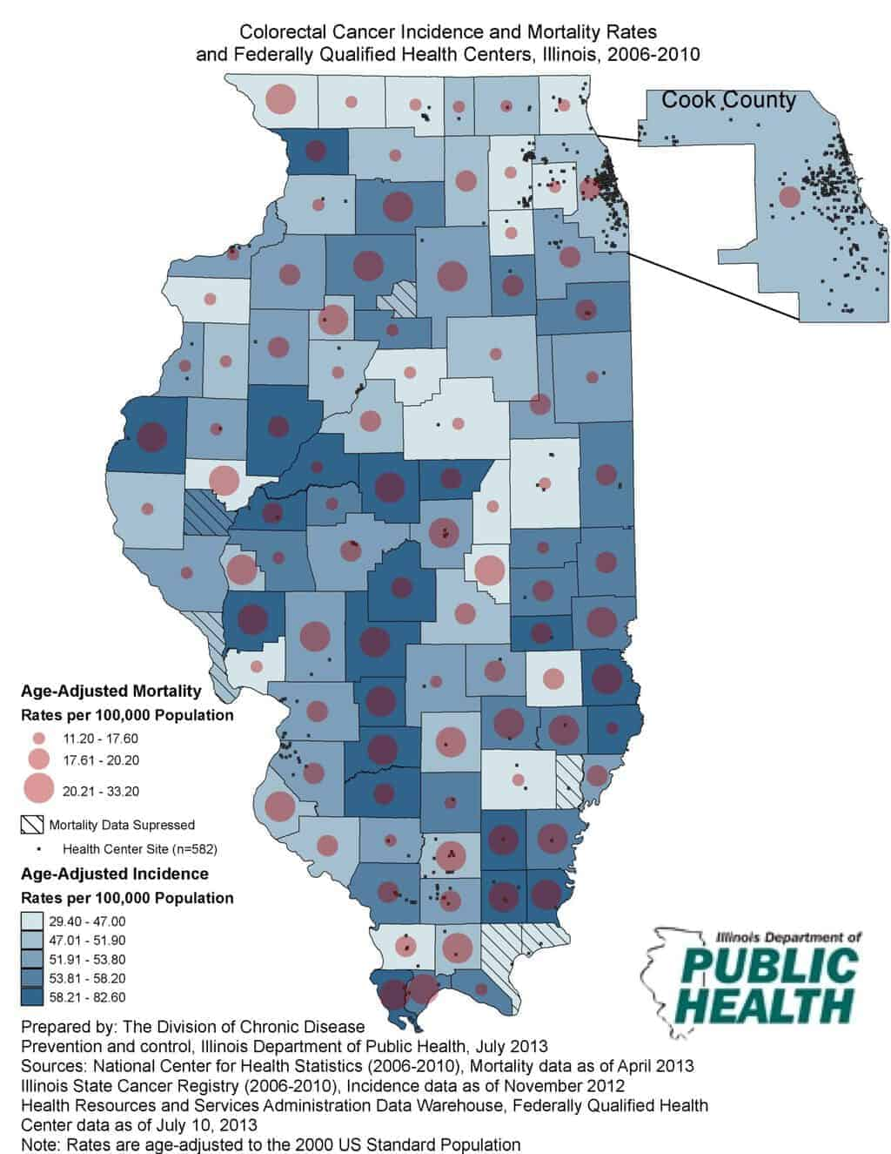

Data processing
Based on the above map showing the prevalence of the cancer disease incidence and the mortality rates, the use of ArcGIS is essential in this case as well. The various point collected on either google maps or by the Global Positioning System (GPS), can be process by the ArcGIS software to produce a map with various areas which the infectious disease is much prevalent.
Geospatial tools used to answer the questions
The various GIS tool necessary in answering the question in understanding WHERE, include buffer tool. This will be able to indicate the various region.

Measuring size, shape and distribution.
To be able to determine the size of the area most affected by an infection, I will be able to calculate the individual geometries which will be able to describe the size of the area. The use of image classification and analysis technique will be necessary in determining geometries from the remotely sensed data. Still the type of data need on this will be the Disease data either in the vector or raster formats.
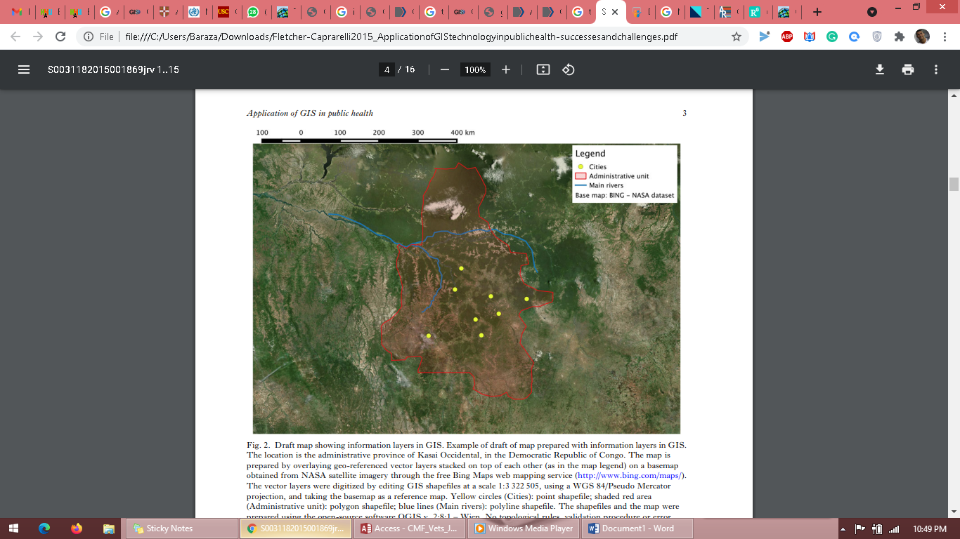
(Stephanie M Fletcher-Lartey and Graziella Caprarelli, 2016)
Draft map show various information layers in Geographic Information System. This was in Congo. The preparation of this map involves overlay of the geo-referenced layers and stacked on each other.

Data processing
With the use of ArcGIS, performing data overlay and buffer in the zone of interest. To be able to answer questions on Measuring size, shape and distribution, using the ArcGIS analysis toolbox, to further make everything clear, I will be able to utilize buffer tool as well as erase tool to be able to remove all that might not be of use.
Geospatial tools used to answer the questions
In answering question relating to size, shape and distribution, I will be able to use the ArcGIS Software, which within, I will utilize the various tools to be able to calculate the area, height, length and centroid distribution and shape. Another geospatial tool will be Remote Sensing, this will be used for the sensed data.

Determining how places are related.
In the comparative maps, the use of color and symbols will be appropriate. An indication of what can be done to change the condition will be appropriate as well. Based on the research done by Salehi, F., & Ahmadian (2017), on the province of Kerman in Iran, they based their study on the health services received by pregnant mothers and their nearby health facilities, taking this as an example, the relationship can be show in various aspect, in areas where there are many health facilities and good health care, then pregnant mothers get very good health care services and areas with small number of health facilities, they tend to receive relatively poor health services.
Basically, the all the information on the number of reproductive women would be contained in the latest census data. The figure on the relationship of medical care and the services received by mothers is indicated is demonstrated below.
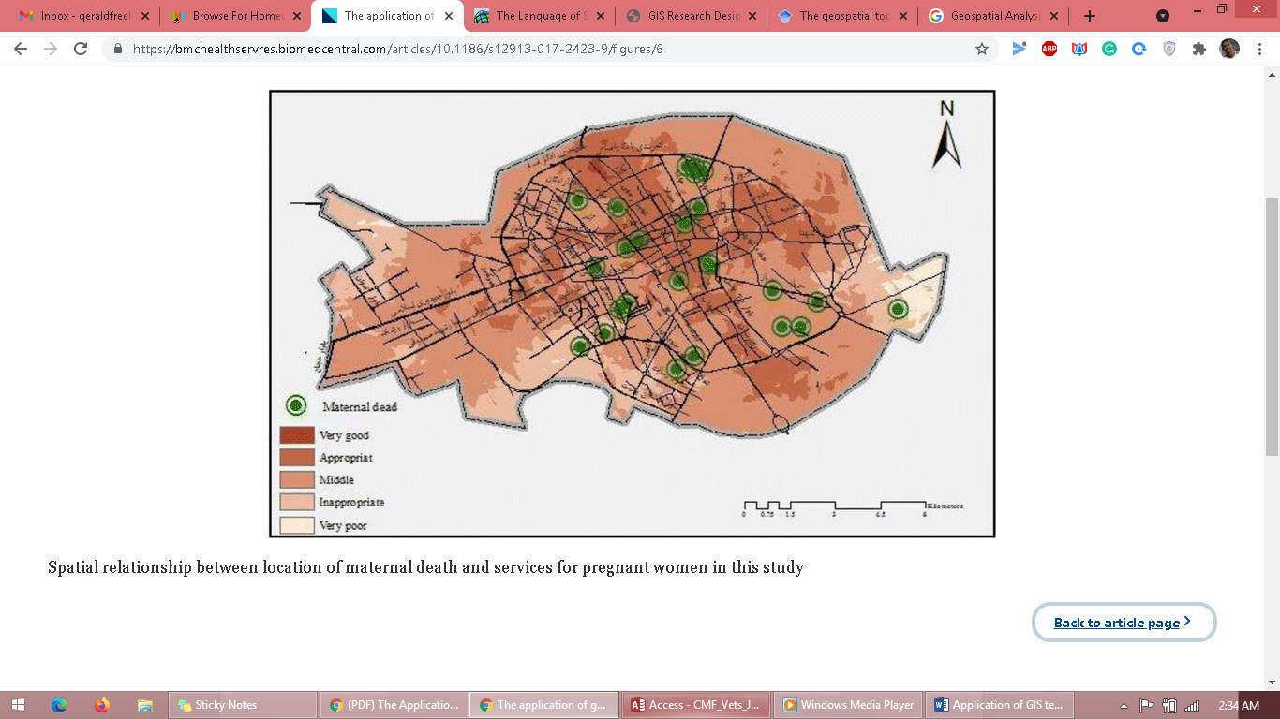
(Salehi, F., & Ahmadian, 2017)
Data geoprocessing
The process would include perform overlays, and perform the proximity and creating buffers among other functions. For this, given the coordinates and tracking data, using the ArcGIS tool, creating buffer and performing proximity will be easily done. The various geoprocessing tools required includes Buffer tool, Erase/Difference tool, clip tool and intersect tool. This will be much useful in identifying boundaries and various close features.

Geospatial tools used to answer the questions
The Geographic information system (GIS) tool to be utilized in the answering the question on the correlation of various aspect,
3. Proposed method(s) for sharing and communicating results
On the various entities mapped, resulted can be communicate by using charts, maps on its own is a method used to communicate findings. Taking an example of explaining data variation of the number of health facilities and the services received, the use of charts would be appropriate.
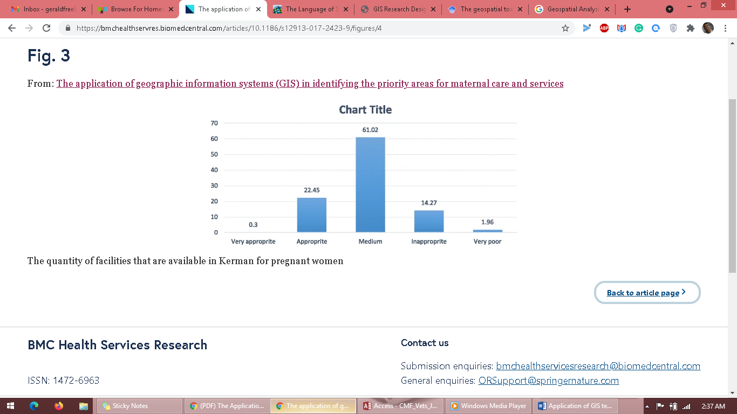
(Salehi, F., & Ahmadian, 2017)

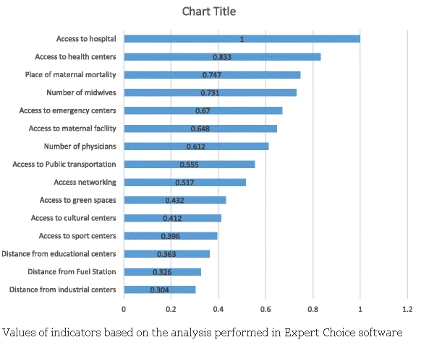
(Salehi, F., & Ahmadian, 2017)
Based on the data collected, the above chart was used to indicate the analytic hierarchy process performed using the overly summation tool in the Arc GIS software.
Other methods which I would propose are conferences, groups as well as sharing the results electronically. If it was a survey on various aspect related to heath, leaving your contacts at the end the sheet will be appropriate.

4. Conclusions
The application of the GIS technology in public health with no doubt has indeed increased, and this is has been due to the increased level of technology and its availability. The inclusion of Geographic Information System (GIS) technology in to the disease and surveillance system would significantly contribute to understanding of various spatial and temporal data which related to the public health. It is also clear that, the use of GIS in the public health and certain regions has not been utilized to the maximum due to various challenges related to infrastructure, maintenance of database for a long period of time among other. The point considered best to be able to elevate the use of GIS in health sector is by building technical capacities in areas which area under-resourced and this will be able to facilitate the use of the technology to manage and solve public health issues.

5. Citations
Stephanie M Fletcher-Lartey and Graziella Caprarelli: (2016) Application of GIS technology in public health; success and challenges. Retrieved on 10th May 2021, https://pubmed.ncbi.nlm.nih.gov/26831619/
Spatial Sciences Institute, University of Southern California (2020): GIS online. Retrieved on 7th may 2021, https://gis.usc.edu/blog/gis-in-the-field-of-public-health/
Salehi, F., & Ahmadian, L. (2017). The application of geographic information systems (GIS) in identifying the priority areas for maternal care and services. BMC health services research, 17(1), 1-8. Retrieved on 8th May 2021, https://bmchealthservres.biomedcentral.com/articles/10.1186/s12913-017-2423-9
Amanda Briney (2014). Overview of Public Health and GIS// GIS LONGE. Retrieved on 7th may 2021. https://www.gislounge.com/overview-public-health-gis/#:~:text=Today%20modern%20GIS%20is%20used,the%20field%20of%20public%20health.&text=This%2C%20combined%20with%20the%20use,component%20in%20public%20health%20research.

